Student Faculty Exchange Program phase 3 on the topic “Bharatheeya Dharm aur Sahitya”
Name of the program- “Bharatheeya Dharm aur Sahitya”
Co-ordinators -Dr Ranjithm, Dr.Surya Boss ,Department of Hindi,MES Asmabi College
Dr. Sr.Rose Anto ,Dept. of Hindi,St.Joseph’s College Irinjalakuda

Program Objectives
In order to foster institutional networking and cultural diversity among the students Department of Hindi of MES Asmabi College in collaboration with Department of Hindi of St.Joseph’s College,Irinjalakkuda conducted Student Faculty Exchange Program phase 3 on the topic “Bharatheeya Dharm aur Sahitya’ on 19.02.2015
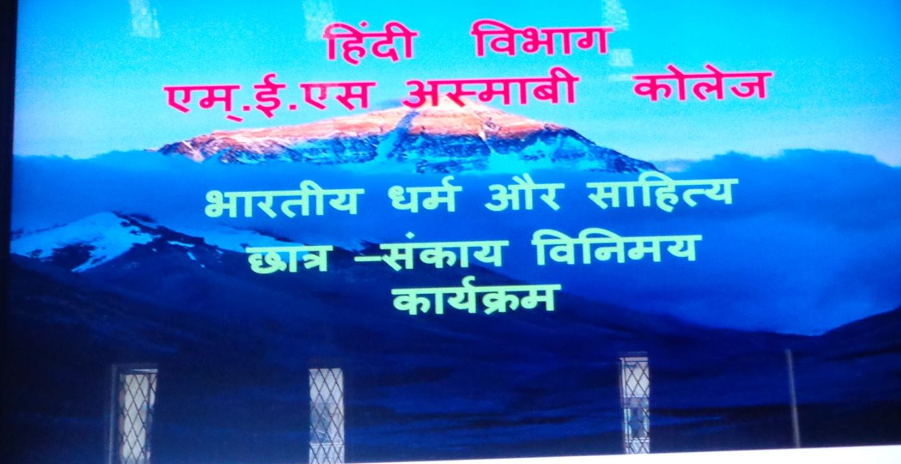
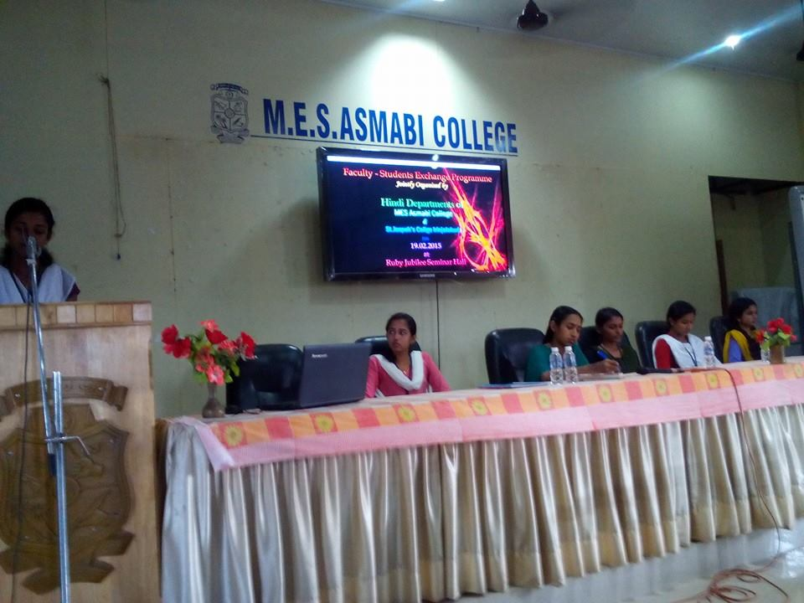
Program participants
Students and faculties from MES Asmabi College and St.Joseph’s College
Report of the Program
The students of both Colleges presented paper on “Bharatheeya Dharm aur Sahitya”. They tried to show the influence of Dharma a on Hindi literature. The papers helped to understand the cultural heritage of our India .
Program Outcomes:
1. Cultural Awareness: Participants gained a deeper understanding of Hindi culture, traditions, and its impact on the global community.
2. Language Promotion: The event encouraged the use and promotion of Hindi language, fostering linguistic diversity and inclusivity.
3.Community Building: The celebration brought together students, faculty, and staff, fostering a sense of community and shared cultural understanding.

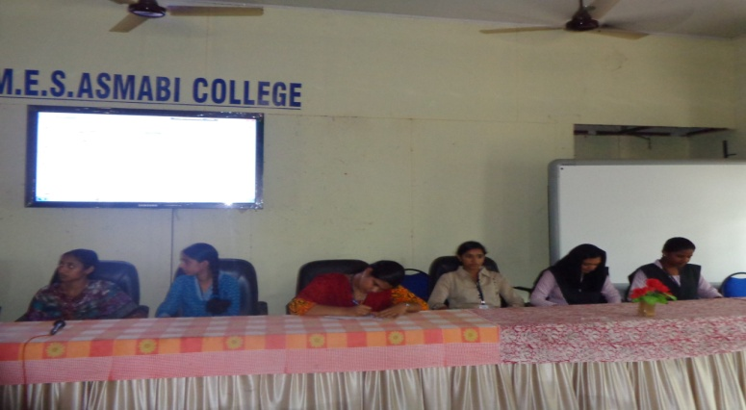

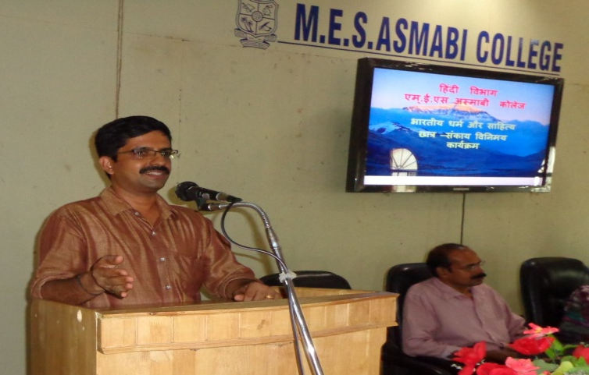
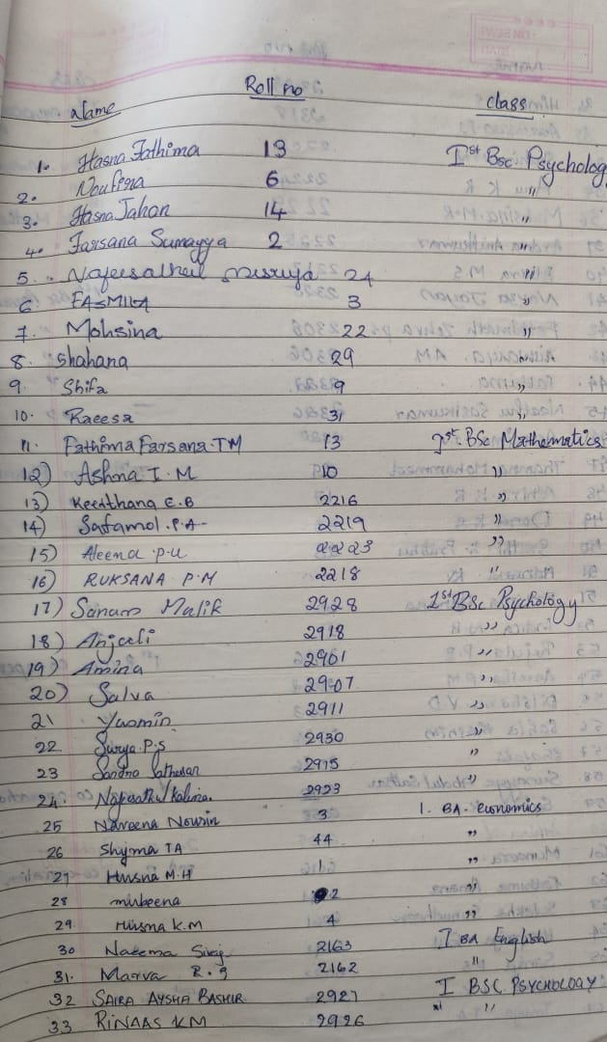
Feedback and Evaluation:
Participants provided positive feedback, expressing appreciation for the event's richness and educational value. They highlighted the importance of such programs in promoting linguistic diversity and intercultural exchange among institutions.

Dr Ranjith M
19.02.2015

