
M.E.S. ASMABI COLLEGE

Re-accredited by NAAC with ‘B++’ Grade
P.Vemballur, P.O. – 680671, Kodungallur, Thrissur Dt.
Email: principal.mesasmabi@gmail.com Web.www.mesasmabicollege.org

Program Report: NATIONAL PSYCHOLOGICAL TRAINING CONFERENCE
Date: February 9-10, 2019
Event Theme: Psychology in Daily Life - A Roadmap to Psychologist
The National Psychological Training Conference, focusing on "Psychology in Daily Life: A Roadmap to Psychologist," took place on February 9 and 10, 2019. The conference aimed to provide a comprehensive understanding of the past, present, and future of psychology in India, explore positive psychology in everyday life, and introduce the principles of behavioral economics.
The National Psychological Training Conference 2019 began with a dynamic inauguration ceremony featuring MES Asmabi College's Chairman and Principal, Dr. Ajims P Mohammed, who delivered a pivotal presidential address. Psychology Circle President Mohammed Sabih provided a concise program abstract. Felicitations came from Self-Financing Director Dr. K P Sumedhan and Program Coordinator Lathif Penath. The Head of the Psychology Department, Sangeetha P S, welcomed participants warmly. The ceremony set a positive tone, emphasizing psychology's role in daily life and aspiring psychologists' journey. Distinguished personalities' presence added gravitas to the event, promising two days of insightful discussions and collaborative learning.
Keynote Speakers:
- Dr. Thilothama Mukherji:
  - Topic: Psychology in India; Reflections from the Past, Realities of Present and Future
- Prof. Dr. Shari:
  - Topic: Positive Psychology in Everyday Life
- Dr. Sudheer B:
  - Topic: An Introduction to Behavioral Economics
Workshops: Twelve workshops were conducted by faculties specializing in various areas of psychology, providing participants with practical experiences and specialized knowledge.
Participants: Approximately 300 students actively engaged in the two-day residential program, contributing to a diverse and dynamic learning environment.
Weightage for Training: The program strategically allocated substantial weightage to the training sessions, focusing on preparing students for the evolving field of psychology.
Valedictory Program: The conference concluded with a valedictory program, featuring the same distinguished individuals who participated in the inaugural session. This segment allowed for reflections on acquired knowledge and the impact of the conference on participants.
Conclusion: The National Psychological Training Conference served as a valuable platform for students to interact with key figures in the field, participate in hands-on workshops, and equip themselves with essential skills for a successful career in psychology. The active support from the college administration and enthusiastic student participation ensured the success of the event.

Coordinator HoD Principal

Programme Brochure:
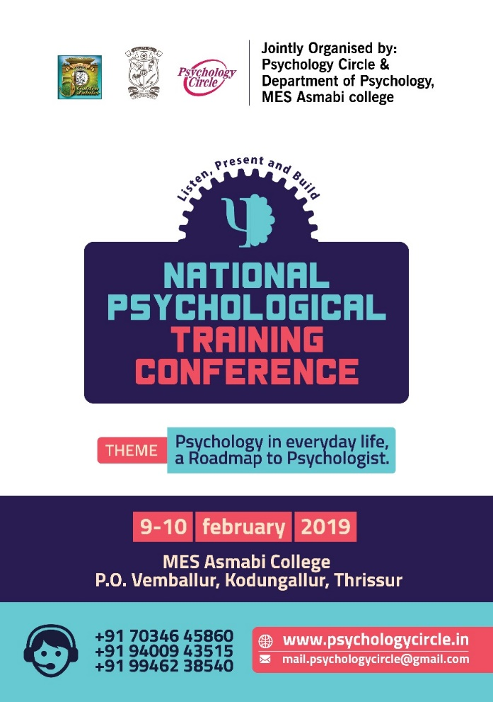
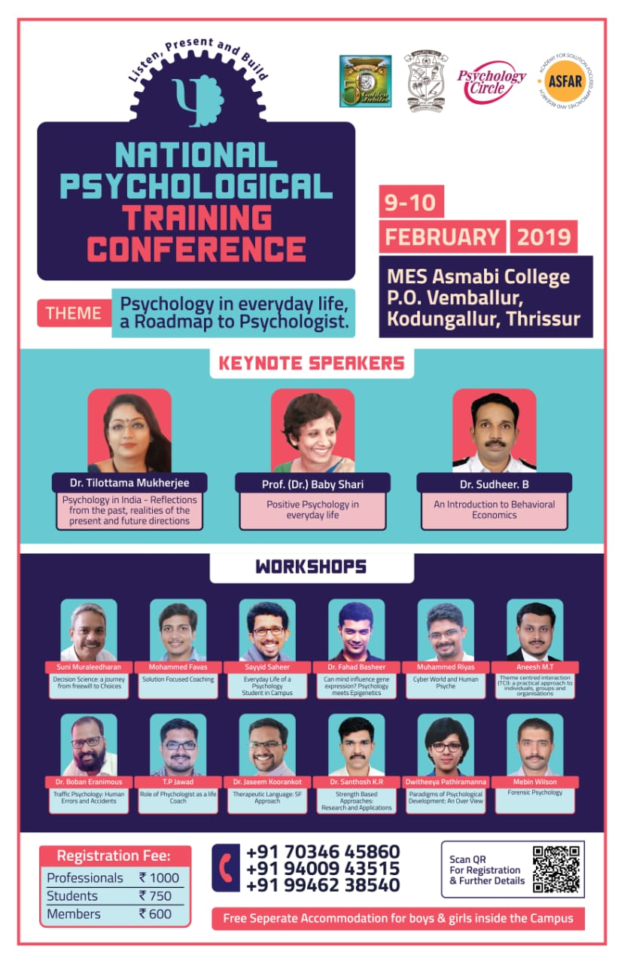

Programme Photos:

