NATIONAL SEMINAR ON HINDI URDU KI SAJHEE VIRASAT
22,23 SEPTEMBER 2016
The Department of Hindi conducted two days National Seminar on Hindi urdu kii sajhee virasat on September 2016 .MES state president Dr.P A Fasal Gafur inaugurated the seminar.Dr Ajims p Muhammed(Principal) presided over the function.Sri K M Abdul salam(Secretar and correspondent),Sri K K Kunju moideen(District President MES Thrissur),Dr K Kesavan(IQAC Cooordinatoor), Sri Muhammed Areej(Staff Secretary) delivered falicitations.Sri.Ishwar Karun Dy General Manger Oriental Insurance Company,Chennai give keynote address.
Dr.C J Babu(Pondicherry),Dr Jayakrishnan(Thrissur),Dr Praneetha(Eranakulam),Sri Velmurkan(Selam),Dr.P Supriya(Kasargod),Rohit tayat(Eranakulam) etc presented papers oon various subjets.
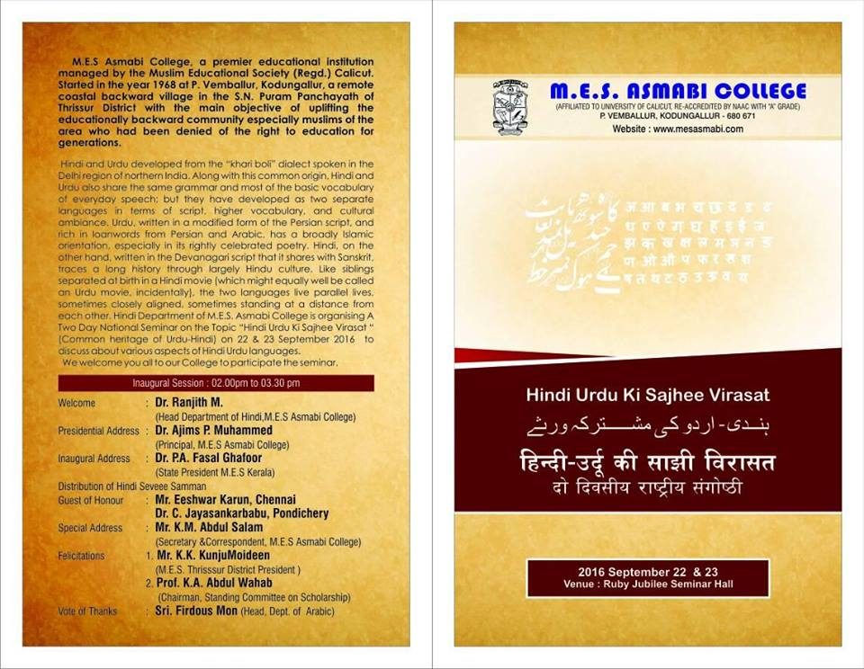
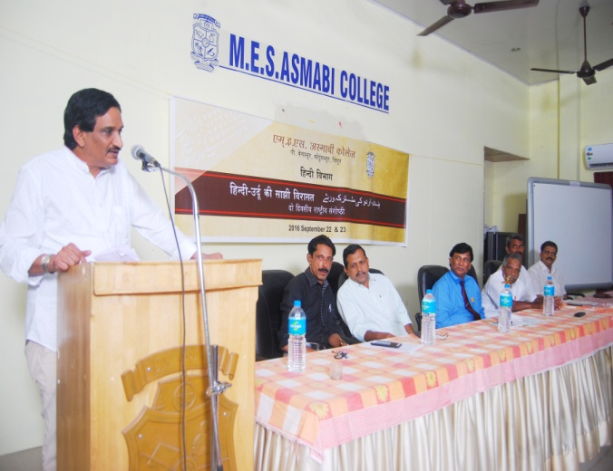
Dr P A Fasal Gafur inaugurating the seminar
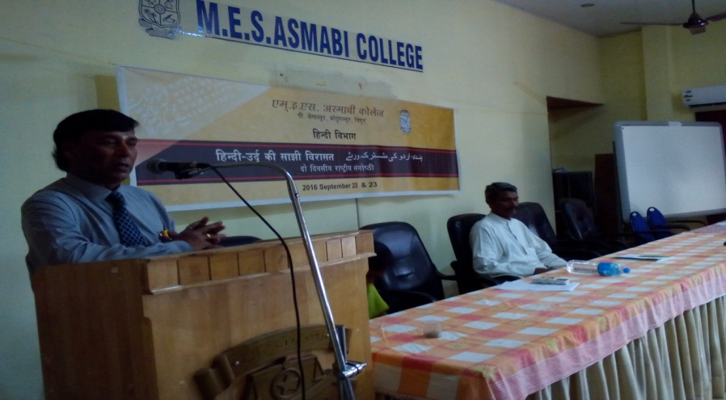
Sri Ishwar Karun Chennai
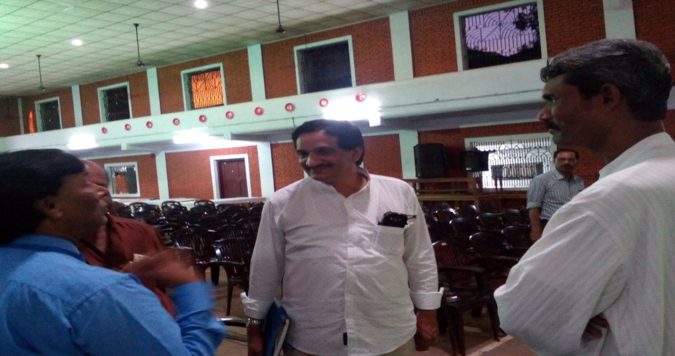
Dr.P A Fasal Gafur
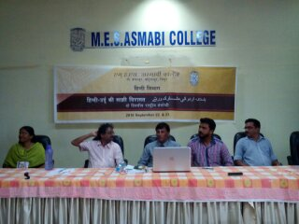
Panel discussion

