MES ASMABI COLLEGE
Fine Arts Club
Annual Report 2022-2023
- International Music Day Celebration on 21st June 2022
Fine Arts Club observed International Music Day at college on 21/6/2022. The Program inaugurated by Dr.A.Biju, Principal, MES Asmabi College. Teachers and students actively participated in the programme.
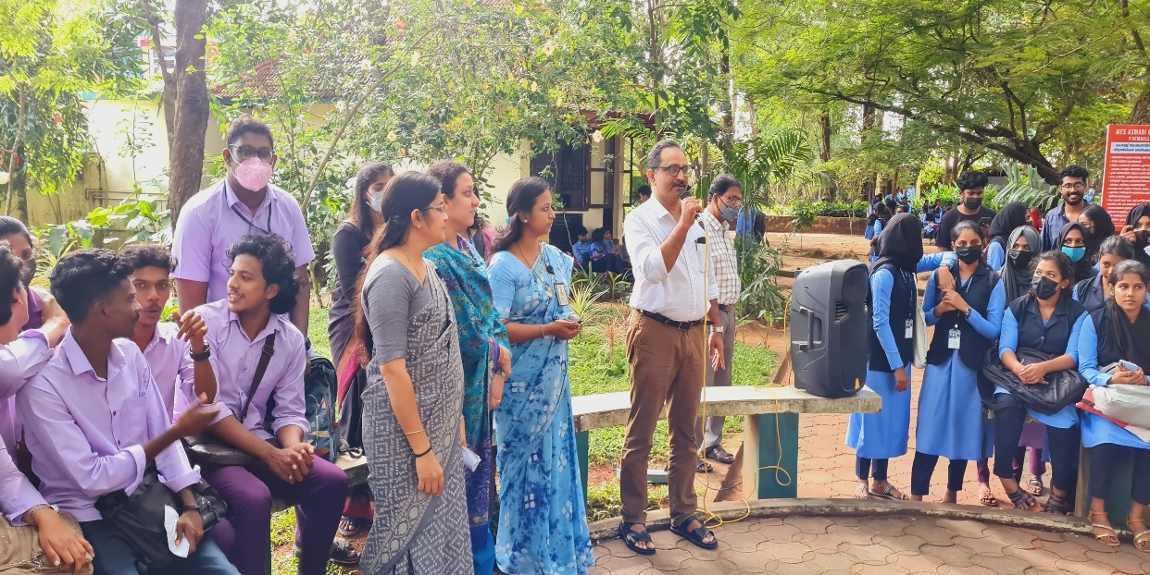
- Azadi ka Amrit Mahotsav (12/08/2022)
Fine Arts Club organized various competitions for students as part of observing Azadi ka Amrit Mahotsav in the college. All departments participated in the event. Competitions included Role Play, Poster Making, Group Song, Group Dance and Rangoli. Department wise competitions really helped in drawing the attention of the students and faculties to this event. Poster making competition was the first item to begin with and the programme ended with the announcement of winners. First position was bagged by Department of Logistics and Department of English secured second position. The event ended with national anthem.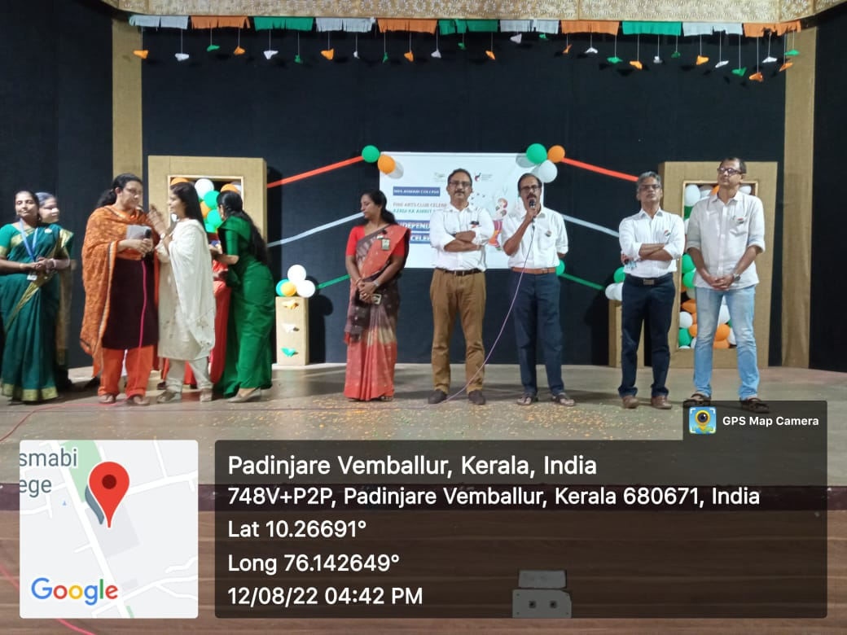 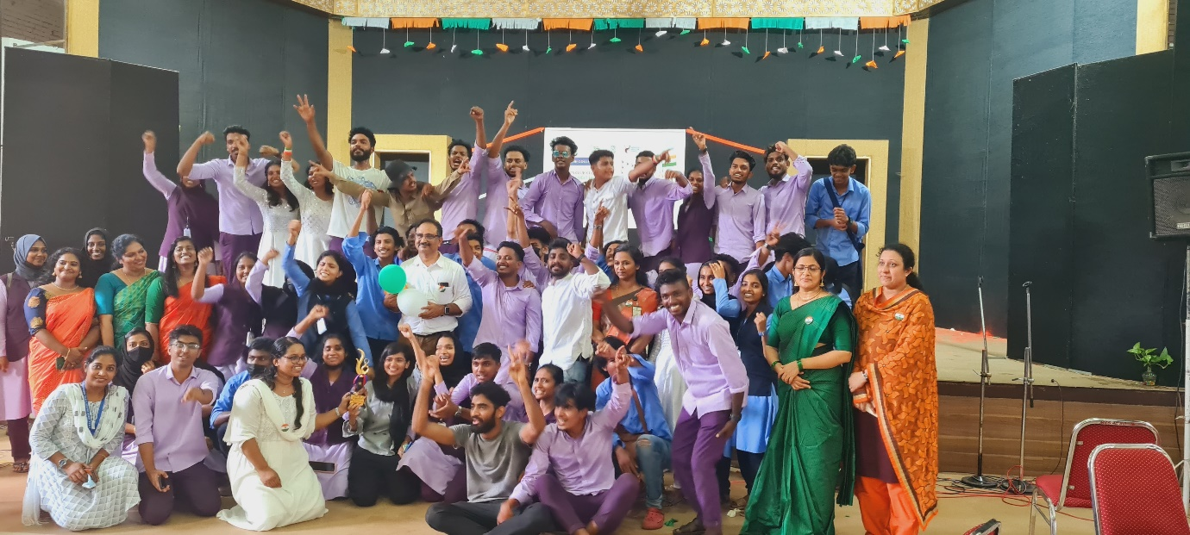
- Onam Celebration with Media One 31st August 2022
Fine Arts Club organized Onam celebration in association with Media One. Media one channel visited the college and they arranged various competitions for students and all departments participated in the event. 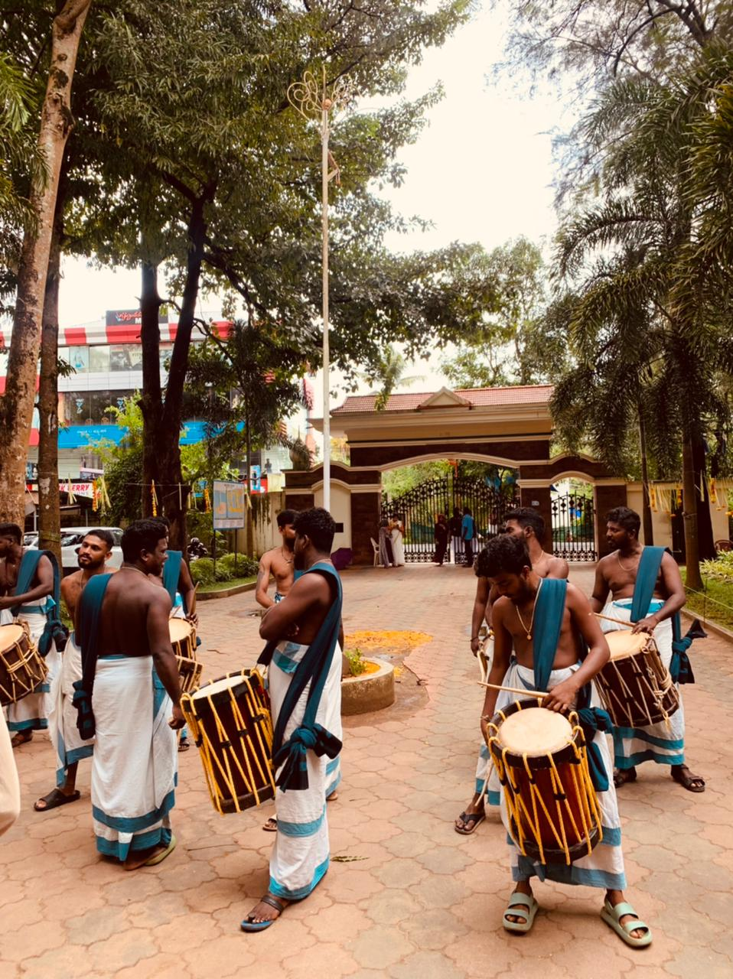
- College Onam Celebration on 1st September 2022
Fine Arts Club organized Onam celebration in the college. Fine arts club arranged various competitions for students and all departments participated in the event.
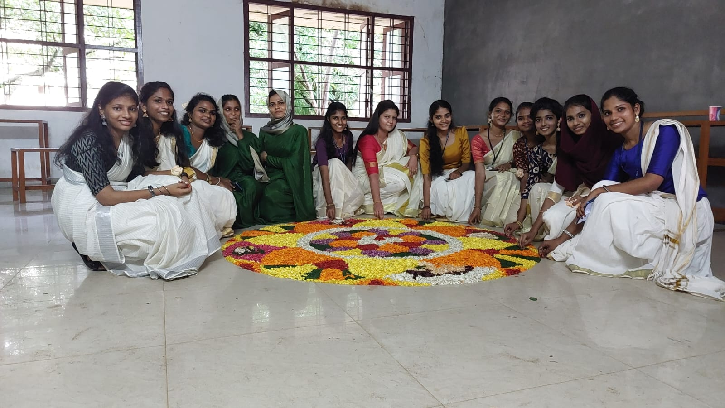
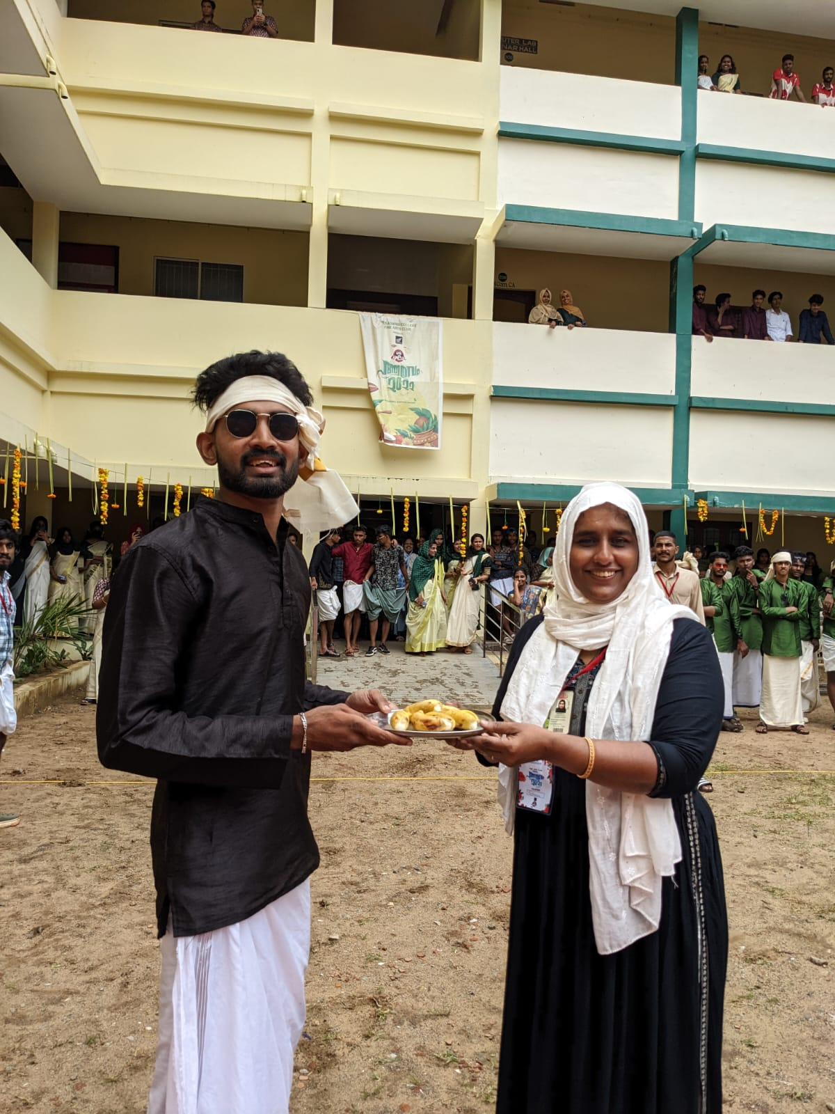
- Nehru Yuva Kendra Arts Festival 29th September 2022
As part of Nehru Yuva Kendra Arts festival which was held at Thrissur Regional Hall MES Asmabi Clollege participated on various programms such as Poem writing, Essay writing, Painting, Debate competition etc. Our students won first prize in poem writing and debate, secpnd price in spot photography.The programme was conducted by Nehru Yuva Kendra Thrissur.
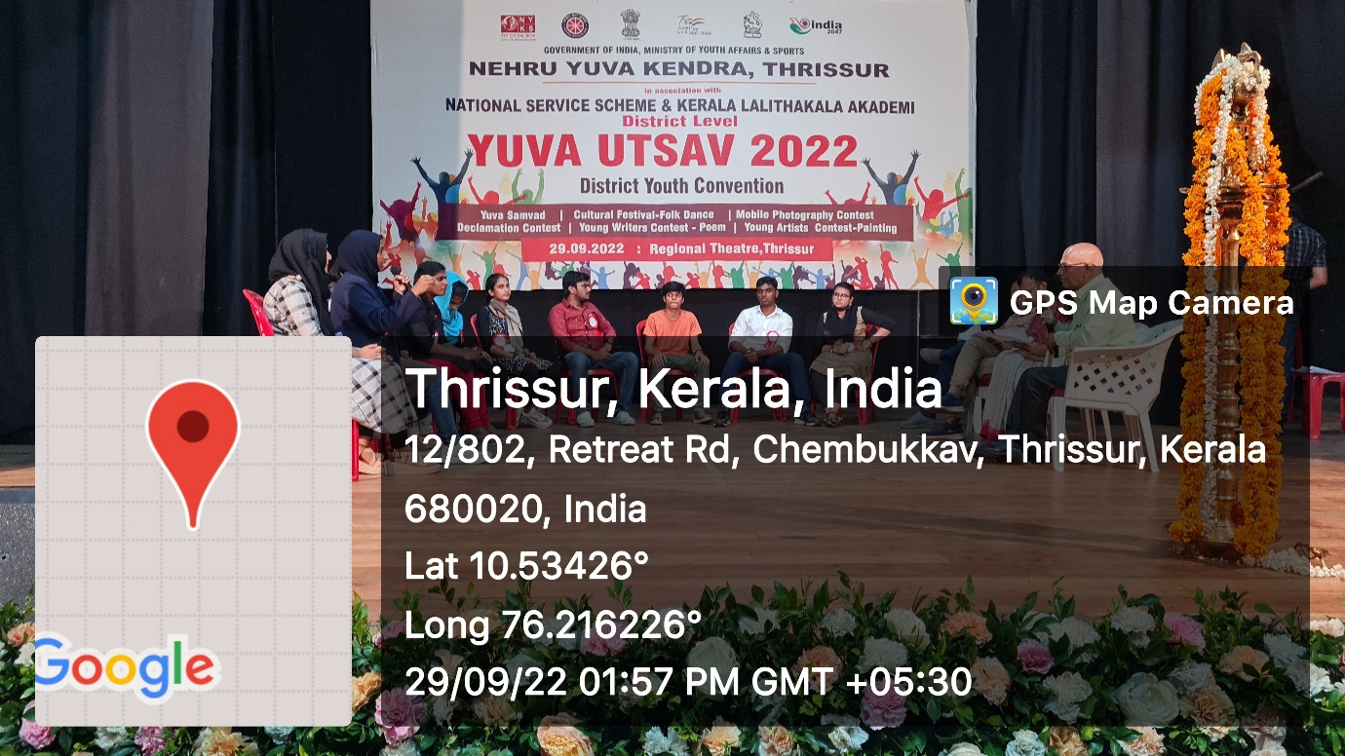
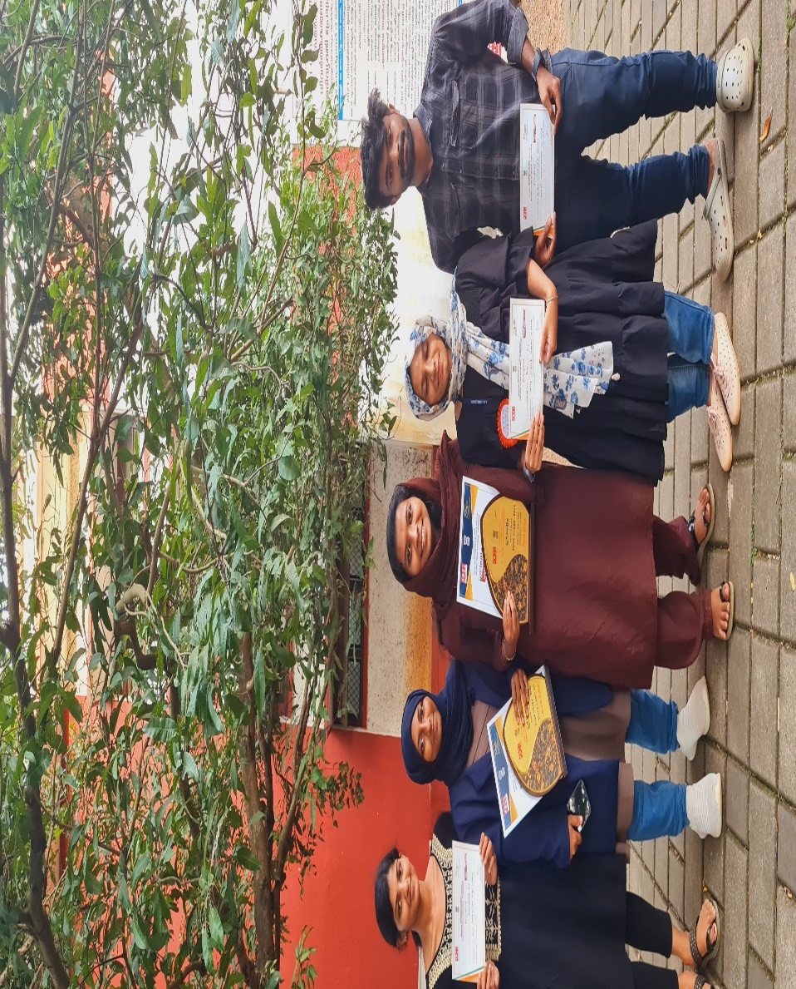

- Mappilapattinte Monjumayi on 27th October 2022

Fine Arts club of MES Asmabi College organized a variety of programme Mappilapattinte Monjumayi on October.The programme actually aimed to find out talented students in the field of arts. The students and teachers actively participated in the program.
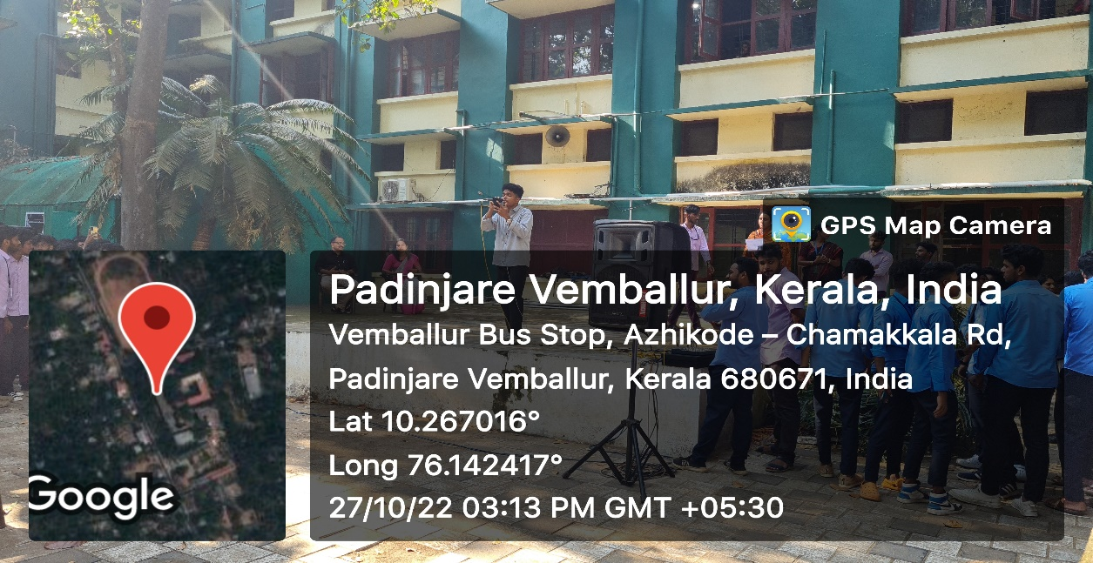

- Rashtradeepika Dance Competition on 29th October 2022
Fine Arts Club of MES Asmabi Clollege participated the students in the Rashtradeepika Dance competitition held at St.Thomas College Thrissur organized by Rashtradeepika daily in the state level.Our college bagged fourth place in the state level competition and won 5000 Rs as price money.
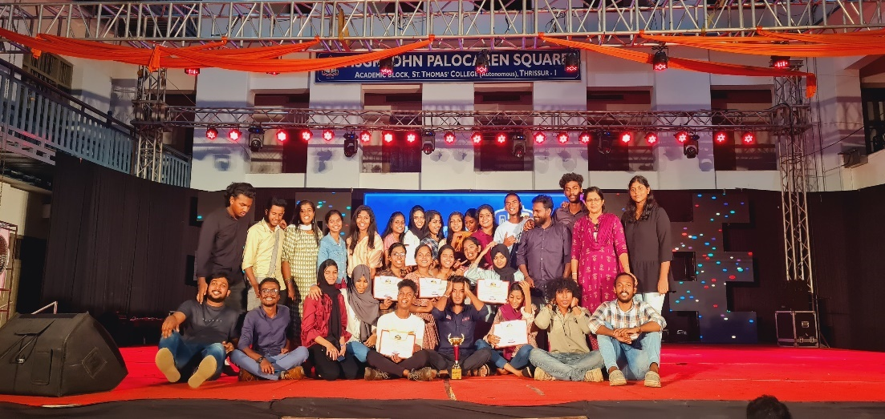
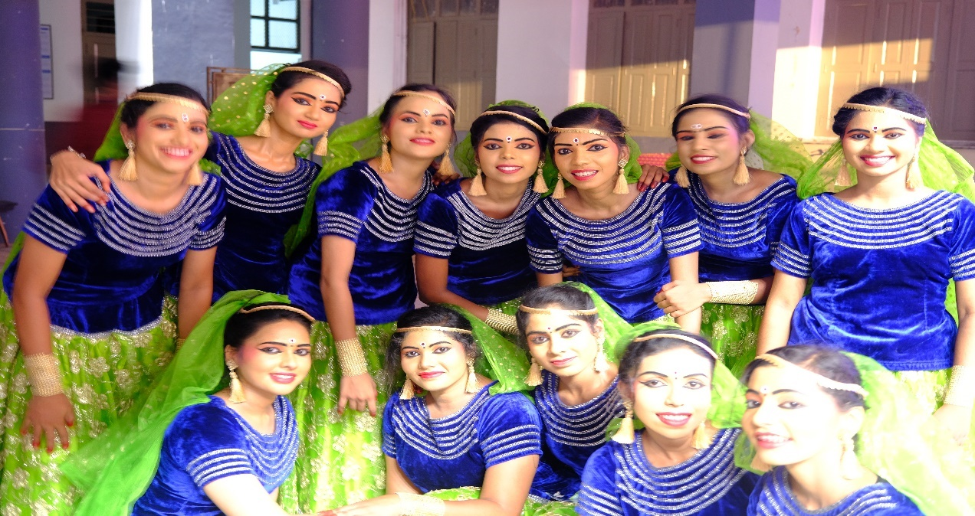
- Milagro…. Intercollegiate Programme
Fine Arts Club of MES Asmabi College has participated the students in the Milagro Intercollegiate programme organized by MES College Marampally. Our college has participated in various competitions such as spot dance, group dance, spot photography Group dance and spot dance won second prize. 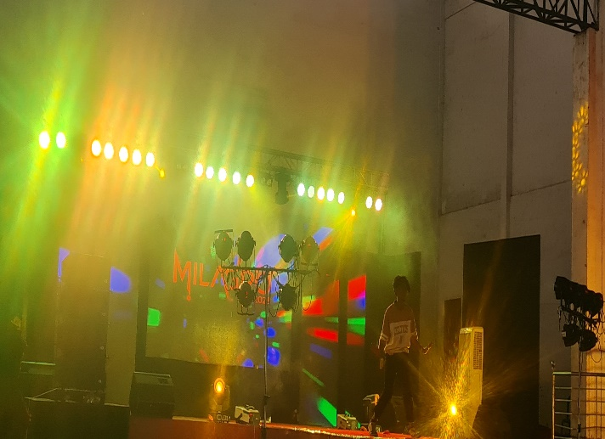 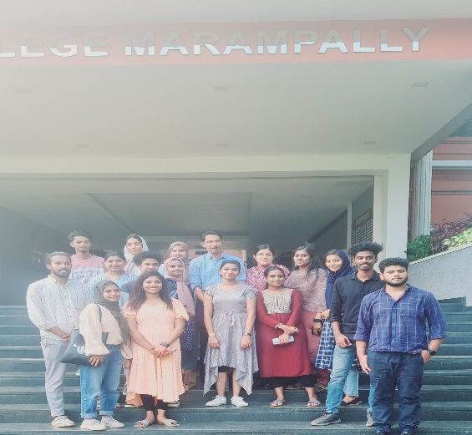
- Fine Arts Day on 13th -16th February 2022
Fine Arts club of MES Asmabi College conducted Fine arts day in association with Bolek College Union on February 13th to 16th 2022.The programme was organised mainly on three stages. Students were divided in to four association such as Commerce, arts, science and B.Voc. Science Team won first prize, arts and B.Voc team won second and third places respectively. 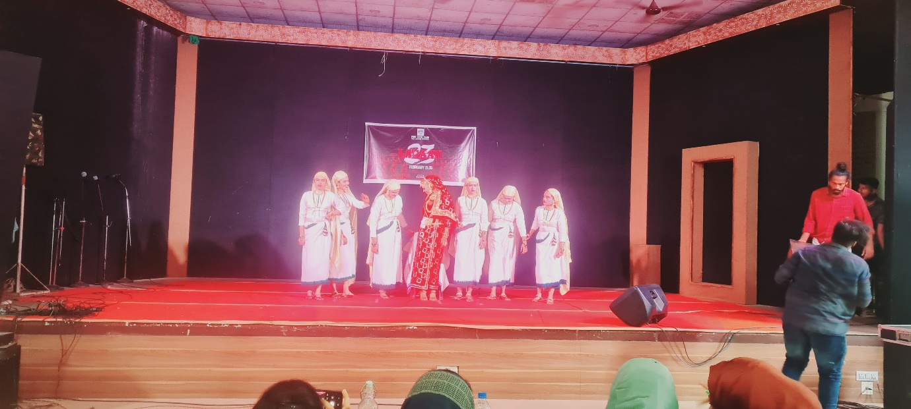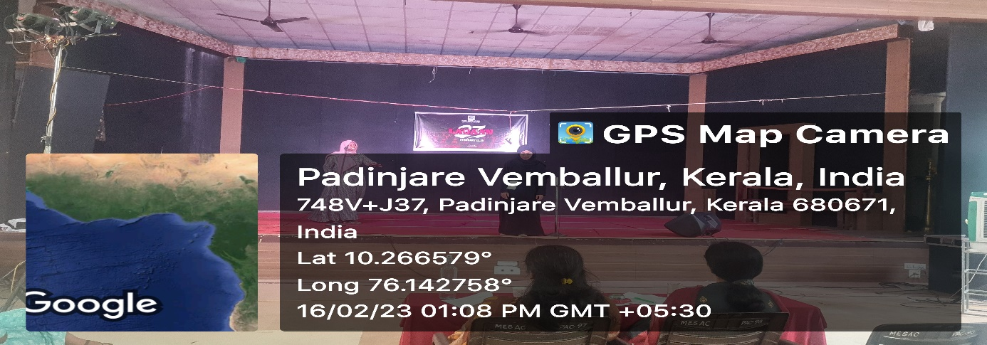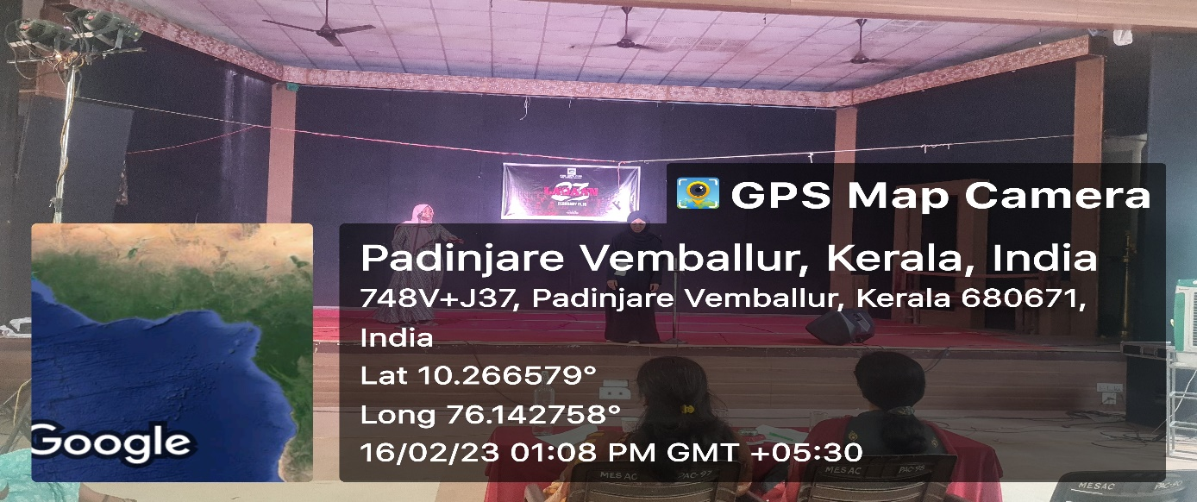
Fine arts club of MES Asmabi College organized several programmes with the limited time. Fine arts members actively involved in all stages of the programmes.

- D-Zone Arts Festival
The D-zone arts festival of the academic year 2022-23 was held on 17th to 21st June at Sree krishna college Guruvayur. Our students have participated in 50 Individual and 17 group items. There was a total of 162 students who have participated in the arts festival. The college has given training for group events. Our students won first prize in Arabic Essay,Arabana muttu,Folk boys, Folk girls, Parichamuttu, Duff muttu and Mapilapattu and second prize in Ganamela,Vattapattu, Gitar, Our college won the first runner up tro phy for the first time in the history of this college with 82 points.

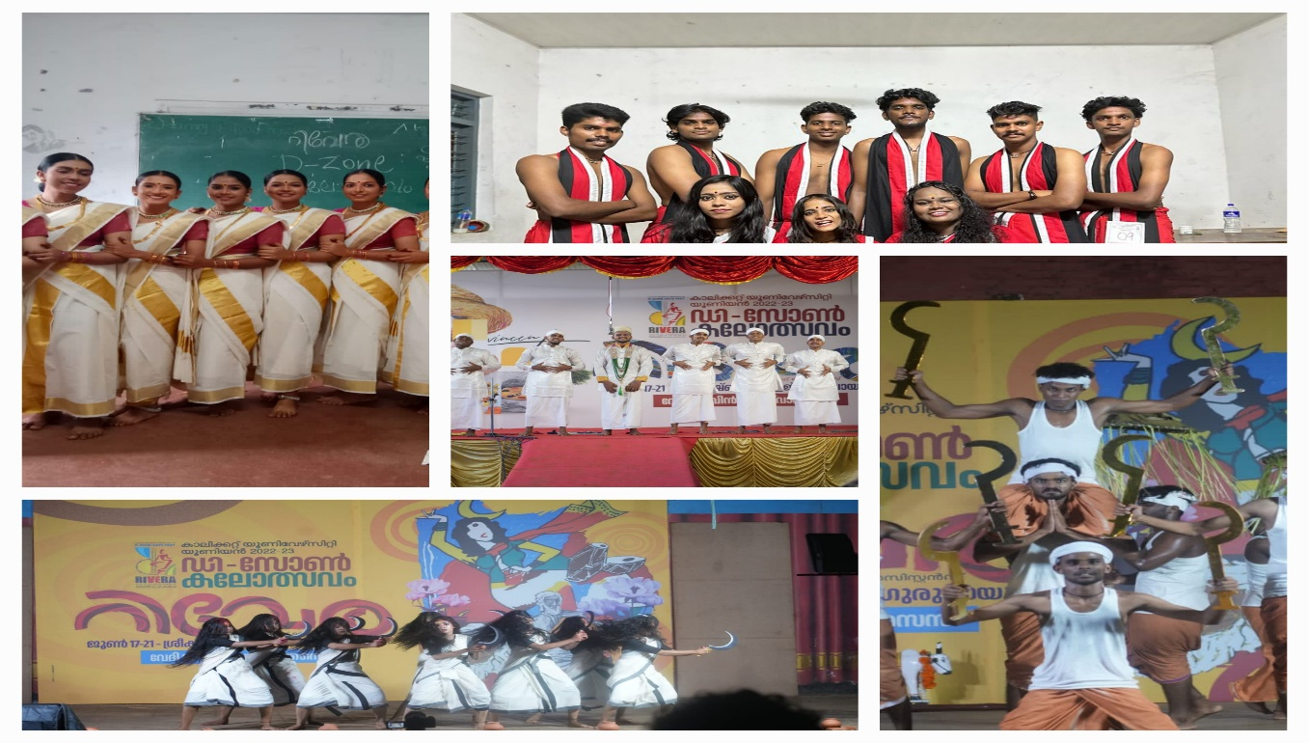

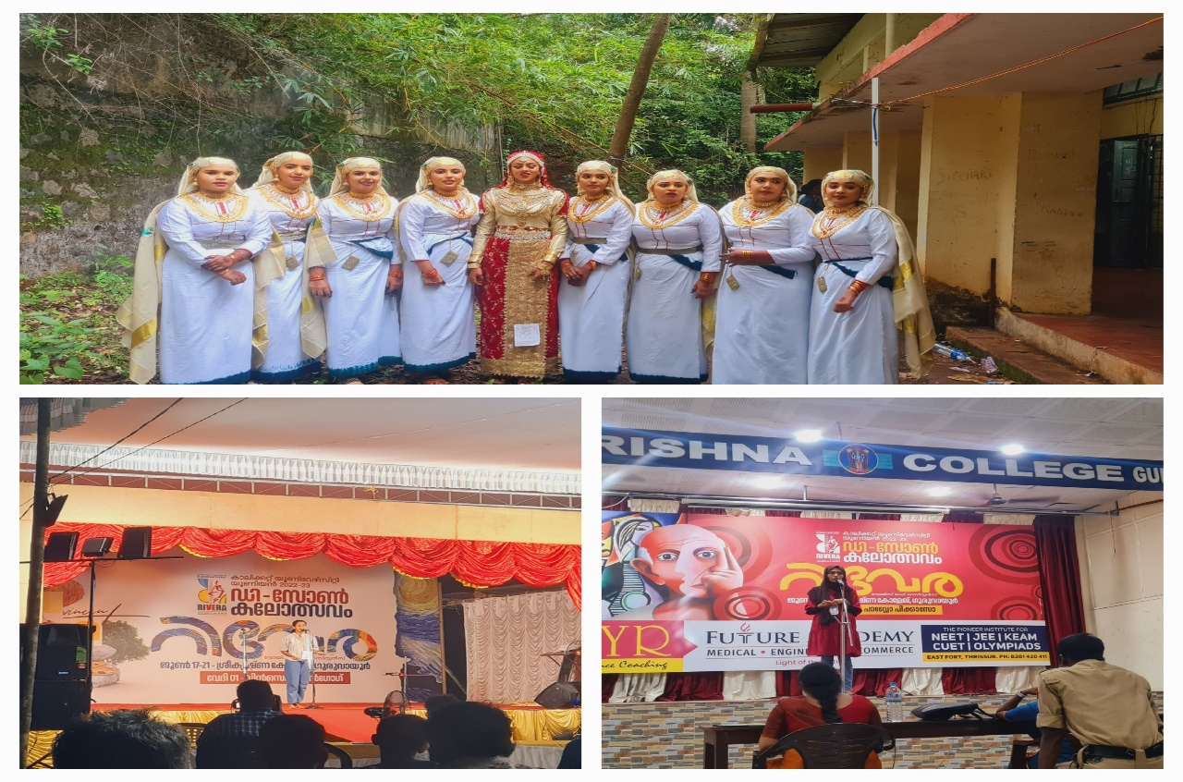
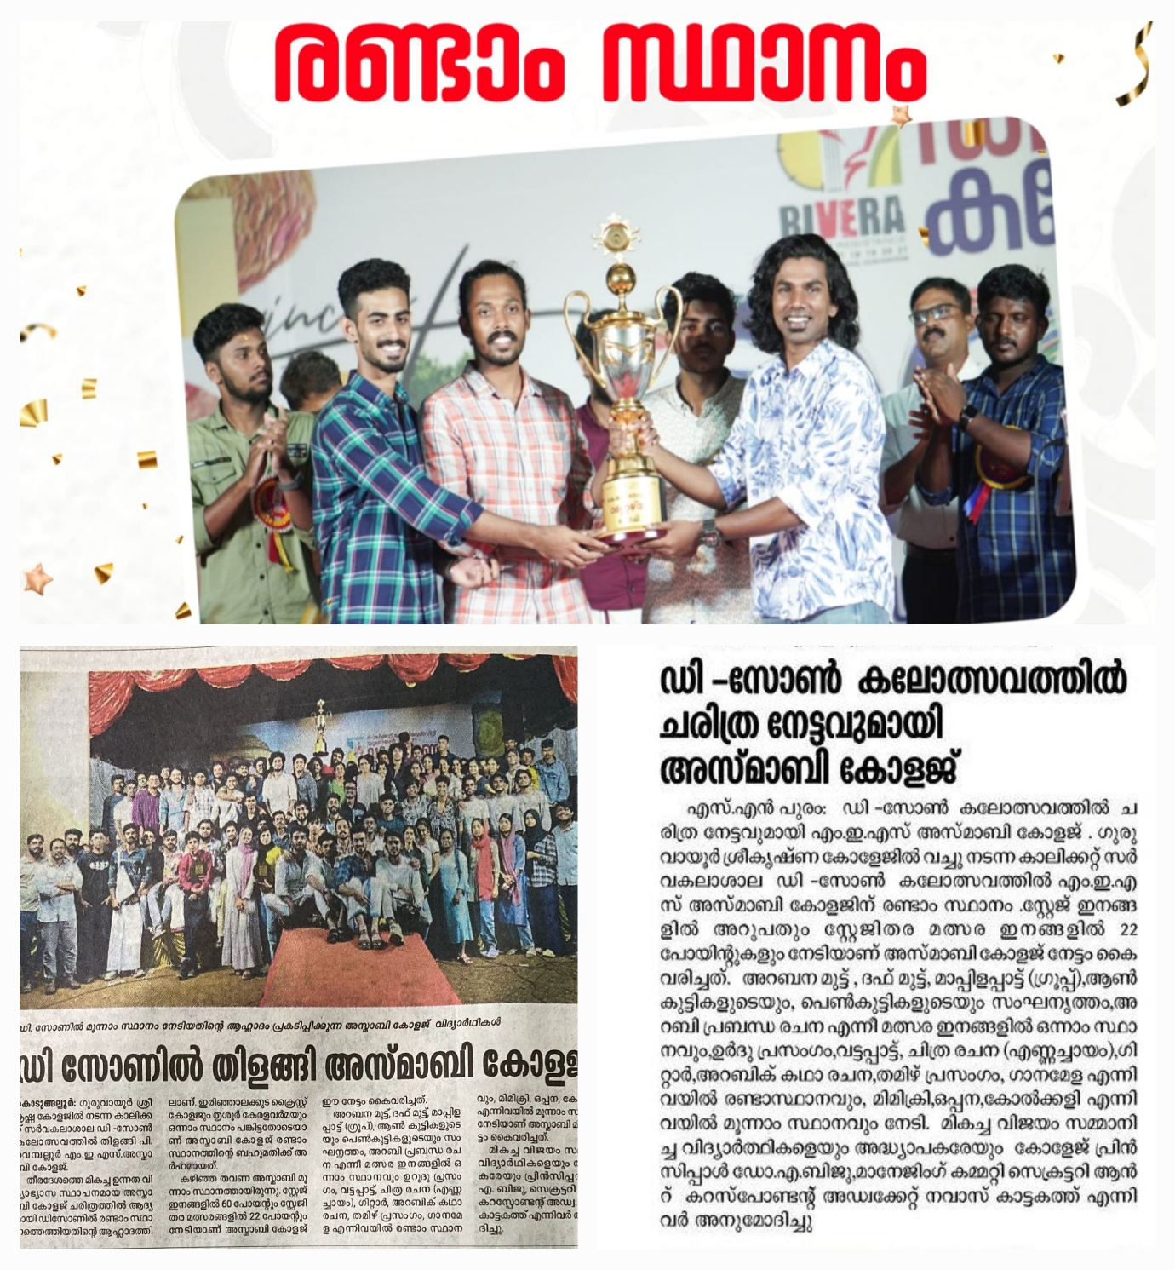

- Inter-zone Arts Festival
- The Inter-zone arts festival of the academic year 2022-23 was held on 12th to 16th July at University of Calicut. Our students have participated in 10 Individual and 7 group items. There was a total of 71 students who have participated in the arts festival. The college has given training for group events. Our students won first prize in Arabic Essay, Arabic Short story,Arabana muttu,Folk boys, Parichamuttu second prize in Duff muttu and Gitar, Our college bagged seventh position in the Interzone arts festival for the first time in the history of this college with 45 points.
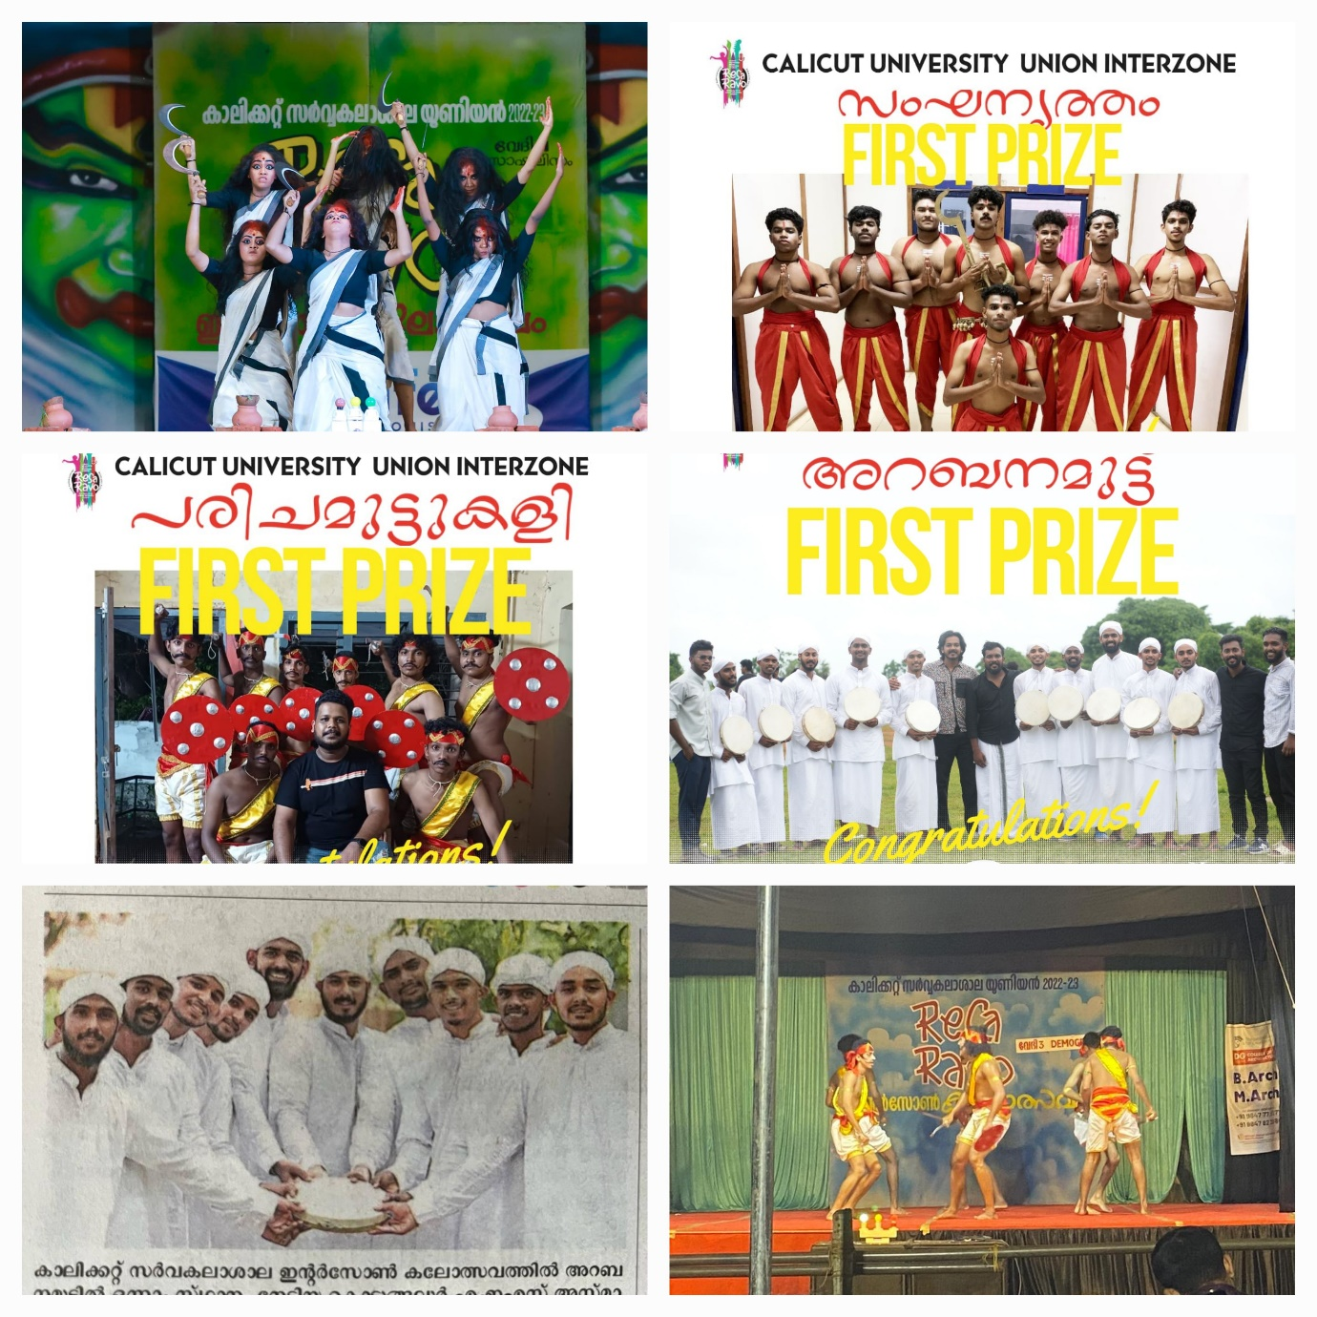
With immense pleasure fine arts club of the college would like to extend the gratitude to the supporters of this successful voyage, Biju sir, Management, teachers, non -teaching Staff and the students.

Thank You

