DEPARTMENT OF COMPUTER APPLICATION
M E S ASMABI COLLEGE, P. VEMBALLUR

REPORT ON GREEN CAMPUS ACTIVITY 1
“THANAL”
PLANT DISTRIBUTION TO STUDENTS
Conducted in collaboration with
Green Campus Initiatives
----------------------------------------------------------------------------------------------------
PROGRAMME HIGHLIGHTS:
Date and venue : 01 March 2023, Department of Computer Application.
Programme Co-ordinator : Nasiya PM (Assiatant Professor,Department of Computer Application)
Student Co-ordinators :Junaid Gafoor (II yr BCA)
:Namsad (II yr BCA)
:Anushya (II yr BCA)
Time : 2.30 PM -3.30 PM

As part of the Green Activity, Department of Computer Application in association with the Green Campus initiative,MES Asmbi College ,P.Vemballur conducted a program namely "Thanal" Plant Distribution to Students on 1/03/2023 at 2:30pm.The program coordinator was Nasiya P M Assiatant Professor,Department of Computer Application.Student coordinators were Junaid Gafoor (II yr BCA),Namsad (II yr BCA) and Anushya(II yr BCA).
Fruit plants were distributed among the students by the HOD Smt.Jabin TH , Assiatant Professor,Department of Computer Application and Program Coordinator Smt.Nasiya PM , Assiatant Professor,Department of Computer Application. Plants of Rose apple,Chikoo,and Rambutan were distributed.Plants were distributed by giving them instructions how to take care of them.Finally the program ended with a vote of thanks by the coordinator Smt.Nasiya P M.Students coordinated really well throughout the whole program.Overall it was a successful event.

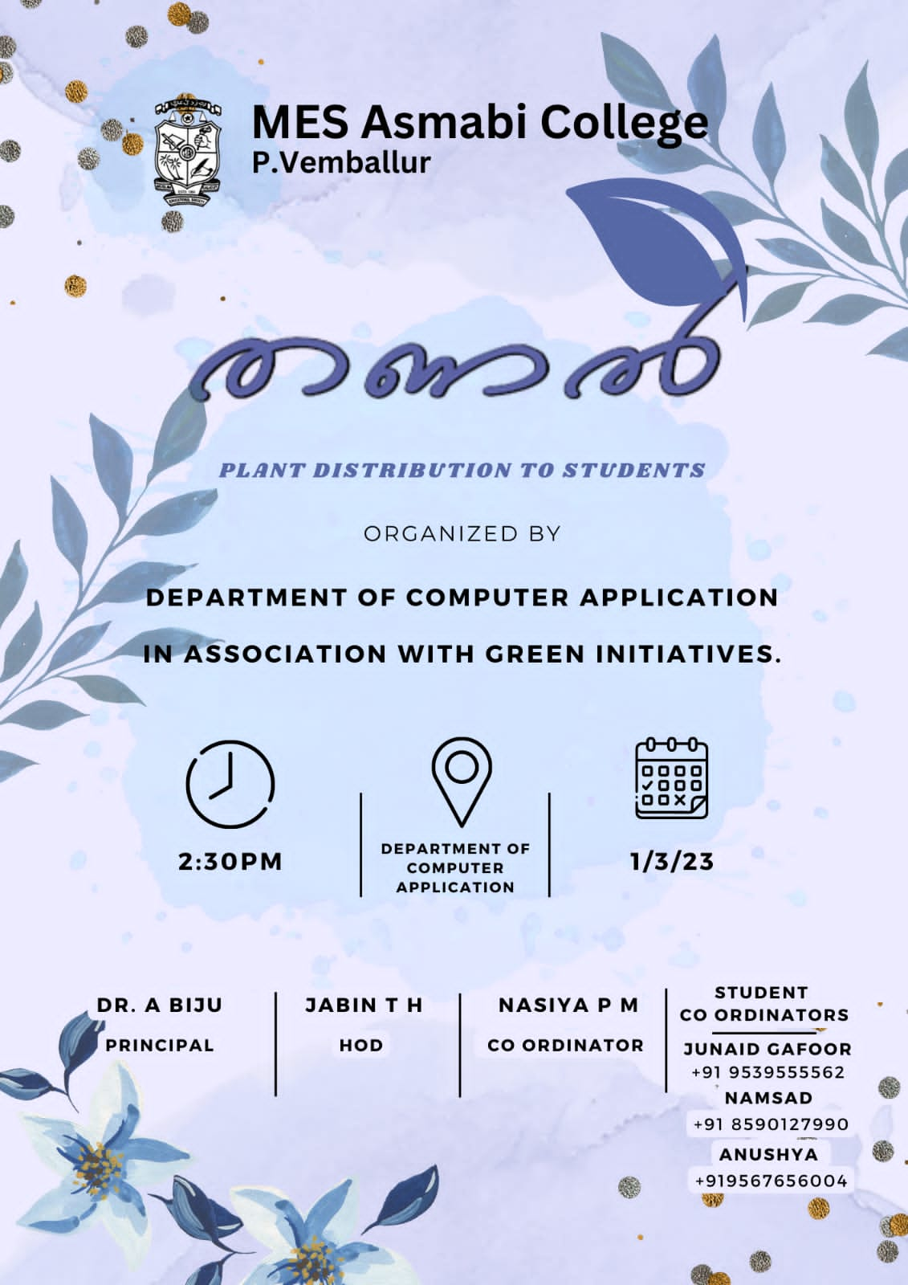
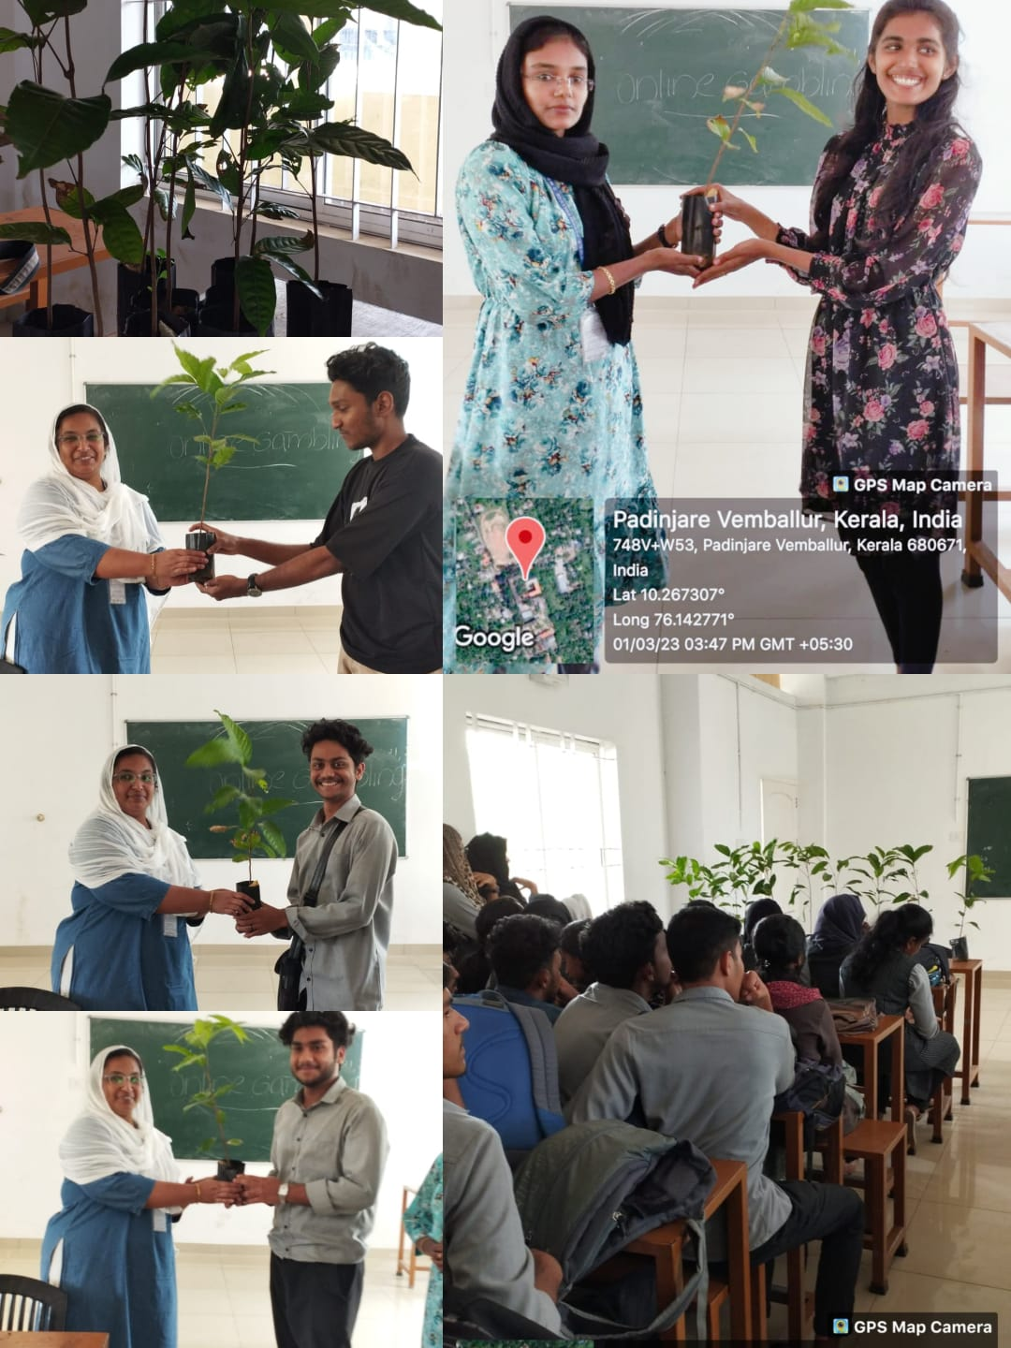
Department of Computer Application Conduct Plant Distribution as a part of Green Campus initiative Programme

